JAVA LAB FAT

CSE1007

REGNO: 20BCE2893

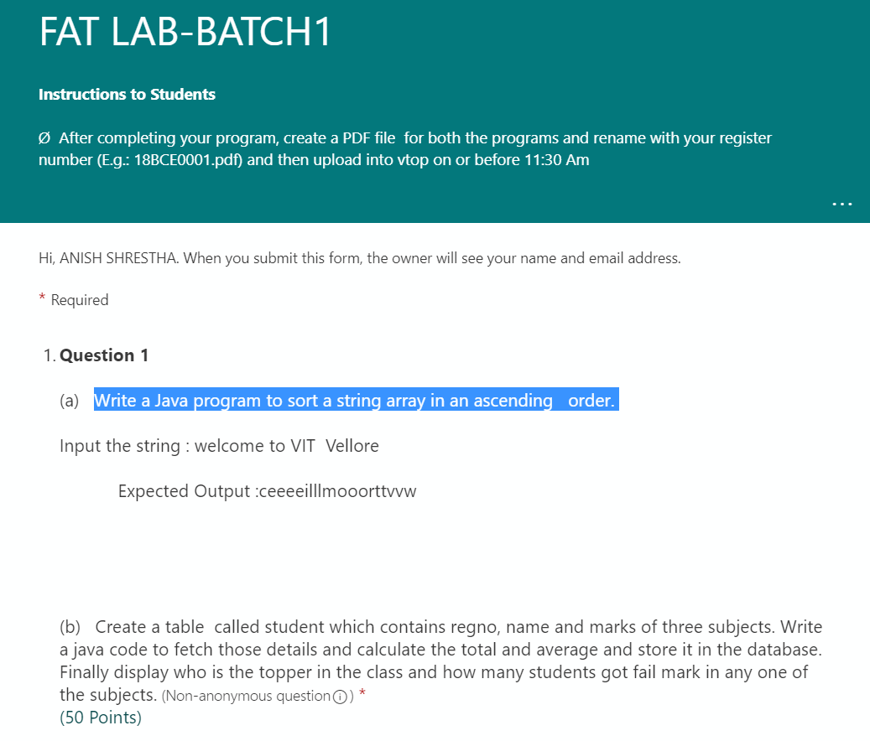

QUESTION NO 1:

CODE:

(Code on visual studio code

#not a screenshot can be copied)

import java.util.\*;

class Arrange {

    public static void main(String[] args) {

        String Takestr;

        String Lowerstr;

        Scanner sc = new Scanner(System.in);

        System.out.println("Enter the string");

        Takestr = sc.nextLine();

        Lowerstr = Takestr.toLowerCase();

        // Converting string into an array for computation

        char sorted[] = Lowerstr.toCharArray();

        char temp;

        //SORTING THE STRING IN ACCENDING ORDER

        int i = 0;

        while (i <= sorted.length) {

            int j = i + 1;

            while (j <= sorted.length - 1) {

                if (sorted[j] < sorted[i]) {

                    temp = sorted[i];

                    sorted[i] = sorted[j];

                    sorted[j] = temp;

                }

                j += 1;

            }

            i += 1;

        }

        sc.close();

        System.out.println("The sorted string in ascending order is:");

        System.out.println(sorted);

    }

}

OUTPUTS:

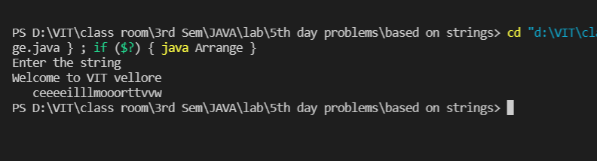

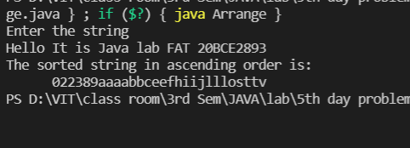

Question no2 :

Code:

import java.sql.\*;

class Labfat1{

public static void main(String[] args) {

Connection con;

PreparedStatement ps;

//java connection

try{

Class.forName("com.mysql.cj.jdbc.Driver");

con=DriverManager.getConnection("jdbc:mysql://localhost:3306/labfat","root","");

//table creation

PreparedStatement pst0=con.prepareStatement("CREATE TABLE Student1 (regno int, Name varchar(225), M1 int, M2 int, M3 int );");

pst0.execute();

System.out.println("TABLE CREATED");

//insert values

PreparedStatement pst1=con.prepareStatement("INSERT INTO Student1 VALUES (105,'Birendra',90,94,91);");

pst1.execute();

PreparedStatement pst2=con.prepareStatement("INSERT INTO Student1 VALUES (101,'Aneesh',45,67,78);");

pst2.execute();

PreparedStatement pst3=con.prepareStatement("INSERT INTO Student1 VALUES (102,'Anupam',56,60,50);");

pst3.execute();

PreparedStatement pst4=con.prepareStatement("INSERT INTO Student1 VALUES (103,'diwendra',45,54,98);");

pst4.execute();

PreparedStatement pst5=con.prepareStatement("INSERT INTO Student1 VALUES (104,'Jitendra',20,25,7);");

pst5.execute();

System.out.println("VALUES INSERTED INTO TABLE");

// Altered table

PreparedStatement pst6=con.prepareStatement("Alter Table Student1 Add total int;");// Altered the table to add Total and average.

pst6.execute();

PreparedStatement pst7=con.prepareStatement("Alter Table Student1 Add Average int;");// Altered the table to add Total and average.

pst7.execute();

System.out.println("Table Altered with marks ");

PreparedStatement pst=con.prepareStatement("select \* from student1");

ResultSet rs=pst.executeQuery();

while(rs.next()){

System.out.println("Regno: "+rs.getString("regno")+" Name: "+rs.getString("Name")+" M1 "+rs.getString("M1")+"M2 "+rs.getString("M2")+" M3 "+rs.getString("M3")+" Total "+rs.getString("Total")+"Average"+rs.getString("Average"));

}

PreparedStatement pst8=con.prepareStatement("INSERT INTO STUDENT1 (TOTAL,AVERAGE ) SELECT SUM(M1+M2+M3),AVG(M1+M2+M3) FROM STUDENT1;");// Altered the table to add Total and average.

pst8.execute();

System.out.println("Total and average Value Inserted ");

System.out.println("Finding Topper In the class");

PreparedStatement pst9=con.prepareStatement("select regno,name where total=max(total); ");

ResultSet rs1=pst.executeQuery();

if(rs1.next()){

System.out.println("ID: "+rs1.getString("regno")+" Name: "+rs1.getString("name"));

}

}catch(Exception e){

System.out.println(e);

}

}

}

Output:

